**File Flow App**

**Mini Project 2-B Report**

Submitted in partial fulfillment of the requirement of University of Mumbai

For the Degree of

**(Computer Engineering)**

**By**

1. **AJAYKUMAR NISHAD ID No: TU3F2021138**
2. **ANIKET TAGADKAR ID No: TU3F2021145**
3. **MAYUR ARGADE ID No: TU3F2021142**

**Under the Guidance of**

**Prof. Dhanashri Dhawale**



**Department of Computer Engineering**

**TERNA ENGINEERING COLLEGE**

**Plot no.12, Sector-22, Opp. Nerul Railway station,**

**Phase-11, Nerul (w), Navi Mumbai 400706**

**UNIVERSITY OF MUMBAI**



**TERNA ENGINEERING COLLEGE, NERUL,**

**NAVI MUMBAI**

**Department of Computer Engineering**

Academic Year 2022-23

**CERTIFICATE**

This is to certify that the mini project 2-B entitled “**File Flow App**” is a bonafide work of

1. **AJAYKUMAR NISHAD ID No: TU3F2021138**
2. **ANIKET TAGADKAR ID No: TU3F2021145**

**3) MAYUR ARGADE ID No.: TU3F2021142**

submitted to the University of Mumbai in partial fulfillment of the requirement for the award of the Bachelor of Engineering (Computer Engineering).

**Guide Head of Department Principal**

**Project Report Approval**

This Mini Project 2-B Report – entitled “**File Flow App**” by following students is approved for the degree of ***B.E. in "Computer Engineering"***.

**Submitted by:**

1. **AJAYKUMAR NISHAD ID No: TU3F2021138**
2. **ANIKET TAGADKAR ID No: TU3F2021145**
3. **MAYUR ARGADE ID No.: TU3F2021142**

Examiners Name & Signature:

1.---------------------------------------------------------

2.----------------------------------------------------------

Date: ---------------------------------

Place: ---------------------------------

**Declaration**

We declare that this written submission represents our ideas in our own words and where others' ideas or words have been included, we have adequately cited and referenced the original sources. We also declare that we have adhered to all principles of academic honesty and integrity and have not misrepresented or fabricated or falsified any idea/data/fact/source in our submission. We understand that any violation of the above will be cause for disciplinary action by the Institute and can also evoke penal action from the sources which have thus not been properly cited or from whom proper permission has not been taken when needed.

|  |  |  |
| --- | --- | --- |
| AJAYKUMAR NISHAD | TU3F2021138 |  |
| ANIKET TAGADKAR | TU3F2021145 |  |
| MAYUR ARGADE | TU3F2021044 |  |

Date: _____________________

Place: _____________________

**Acknowledgement**

We would like to express our sincere gratitude towards our guide **Prof. Dhanashri Dhawale**, Mini Project Coordinators **Dr. Siddharth Hariharan** for their help, guidance and encouragement, they provided during the project development. This work would have not been possible without their valuable time, patience and motivation. We thank them for making our stint thoroughly pleasant and enriching. It was great learning and an honor being their student.

We are deeply thankful to **Dr. Seema Bide (H.O.D Computer Department)** and entire team in the Computer Department. They supported us with scientific guidance, advice and encouragement, they were always helpful and enthusiastic and this inspired us in our work.

We take the privilege to express our sincere thanks to **Dr. L. K. Ragha**our principal for providing the encouragement and much support throughout our work.

|  |  |  |
| --- | --- | --- |
| AJAYKUMAR NISHAD | TU3F2021138 | --------------------------- |
| ANIKET TAGADKAR | TU3F2021145 | --------------------------- |
| MAYUR ARGADE | TU3F2021142 | --------------------------- |

Date: _____________________

Place: _____________________

**Index**

|  |  |  |
| --- | --- | --- |
| TABLE OF CONTENTS | | |
| Sr. No. | **Title** | **Page No.** |
| 1 | Introduction   * 1. Long Intro   2. Problem Definition   3. Objectives | 8  8  9 |
| 2 | Literature Review | 10 |
| 3 | * 1. Methodology   2. Flow Chart   3. Algorithm | 11  12  13 |
| 4 | Result | 13-16 |
| 5 | 5.1 Conclusion  5.2 Future Scope | 17  18 |
| 6 | References | 19 |

**Lists of Tables**

|  |  |  |
| --- | --- | --- |
| Table no. | Table Name | Pg.no. |
| 2 | Literature Review | 10 |

**Lists of Figures**

|  |  |  |
| --- | --- | --- |
| Figure no. | Figure Name | Pg.no. |
| 3.1  3.2 | Flow Chart  Algorithm | 12  13 |
| 4.1  4.2  4.3  4.4  4.5 | Screenshot for Home page  Screenshot for Navigation menu  Screenshot for Share option  Screenshot for Send option  Screenshot for Send Received History page | 14  14  15  15  16 |

**Chapter 1**

**Introduction**

**1. Short Introduction:**

This project is named as *File Flow app*. File flow app is inspired from xender, share IT*.* The File Flow app was made using Android studio. A file sharing app is a software application that enables users to share digital files such as documents, images, videos, music, and more over a network or the internet. File sharing apps can be designed for various purposes, including collaboration, backup, and sharing large files that cannot be sent via email. These apps typically include features such as file storage, synchronization, and sharing capabilities. File sharing apps can be used for personal or professional purposes. In the workplace, file sharing apps can facilitate collaboration between team members, allowing them to share documents and files with one another in real-time.

**2. Problem Definition:**

Many users find it difficult to share and collaborate on files with their colleagues or friends from mobile to pcs and laptops. Lack of necessary security measures to protect sensitive information from being intercepted or leaked. Not user-friendly, making it difficult for less tech-savvy individuals to effectively use the app. Slow or unreliable performance, affecting real-time communication and collaboration. The problem with file sharing apps can vary depending on the context of their use.

**3. Objectives**:

* File flow app aims to provide fast file transfer speeds, allowing users to quickly share files with friends and family.
* File flow app aims to provide an intuitive and user-friendly interface that makes it easy for users to share files without any technical knowledge.
* The objectives of a file sharing app can vary depending on its purpose and the needs of its users.
* A file sharing app can also help to improve productivity by reducing the time and effort required to share files between team members.

**Chapter 2**

**Literature Review**

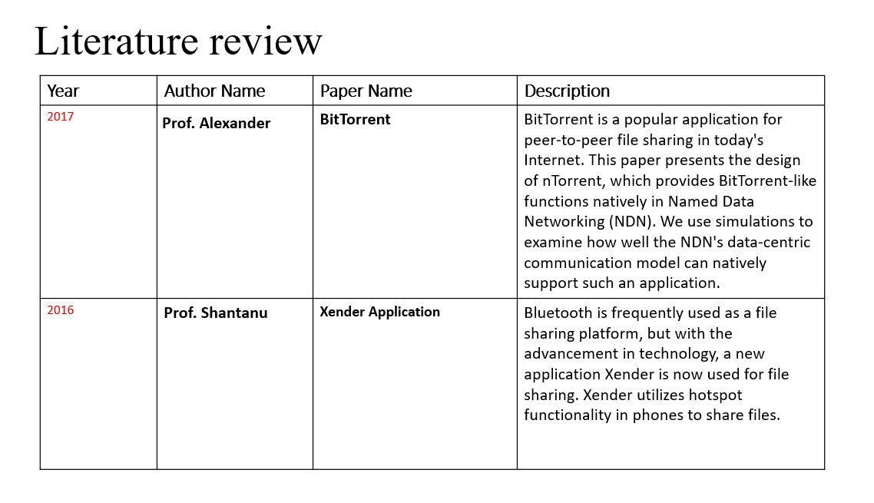 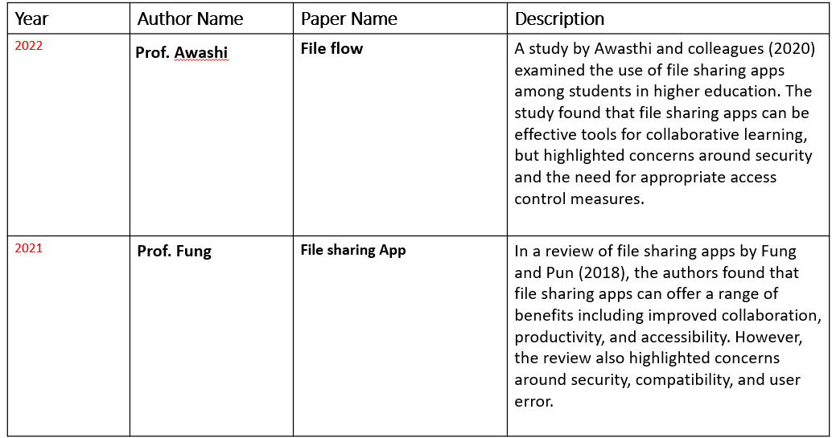

**Chapter 3**

**3.1 Methodology**

The methodology for developing a file sharing app will vary depending on the specific project requirements, but here are some general steps that may be involved:

**Requirement gathering**: The first step in developing a file sharing app is to gather requirements from stakeholders, including end-users, business owners, and technical experts. This involves identifying the key features, functionality, and performance requirements for the app.

**Design:** The next step is to design the architecture and user interface of the file sharing app. This involves creating wireframes, prototypes, and design mockups to help stakeholders visualize the final product.

**Development:** Once the design is approved, the app development process begins. This involves writing code, integrating APIs, and testing the app on different platforms to ensure it works as intended.

**Testing:** After the app is developed, it undergoes rigorous testing to ensure it meets the requirements and is free of bugs and errors. This involves both manual and automated testing to ensure the app is reliable and secure.

**Deployment**: Once the app passes testing, it is deployed to a production environment where end-users can access it.

**3.2 Flow chart:**

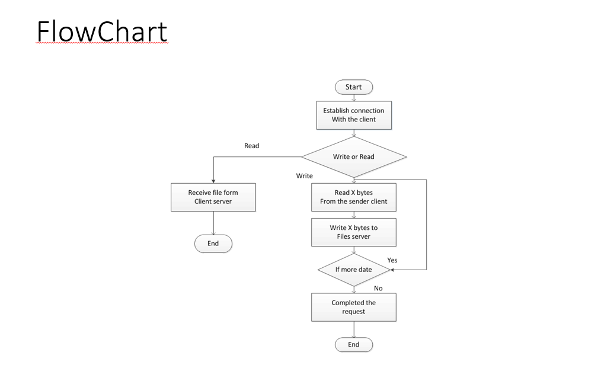

**3.3 ALGORITHM:**

**User** **authentication**: The first step in a file sharing algorithm is to authenticate the user's identity to ensure that they have the appropriate permissions to access and share files.

**File** **upload**: Once the user is authenticated, they can upload files to the app's server. The algorithm may include checks to ensure that the file type and size are acceptable and that the user has the appropriate permissions to upload the file.

**File** **storage**: After the file is uploaded, the algorithm will store the file in a secure location on the app's server. The algorithm may also include mechanisms to encrypt the file to ensure its security.

**File** **sharing**: Once the file is stored on the server, the algorithm will allow the user to share the file with other users or groups.

**File** **download**: When a user downloads a file from the app, the algorithm will retrieve the file from the server and transfer it to the user's device. The algorithm may include checks to ensure that the file is being downloaded by an authorized user and that the download is secure and reliable. Overall, the file sharing algorithm will aim to provide a secure and efficient platform for sharing and storing files while also ensuring that only authorized users can access and modify the files.

**Chapter 4**

**Result**

4.1.Home Page: 4.2. Navigation Menu

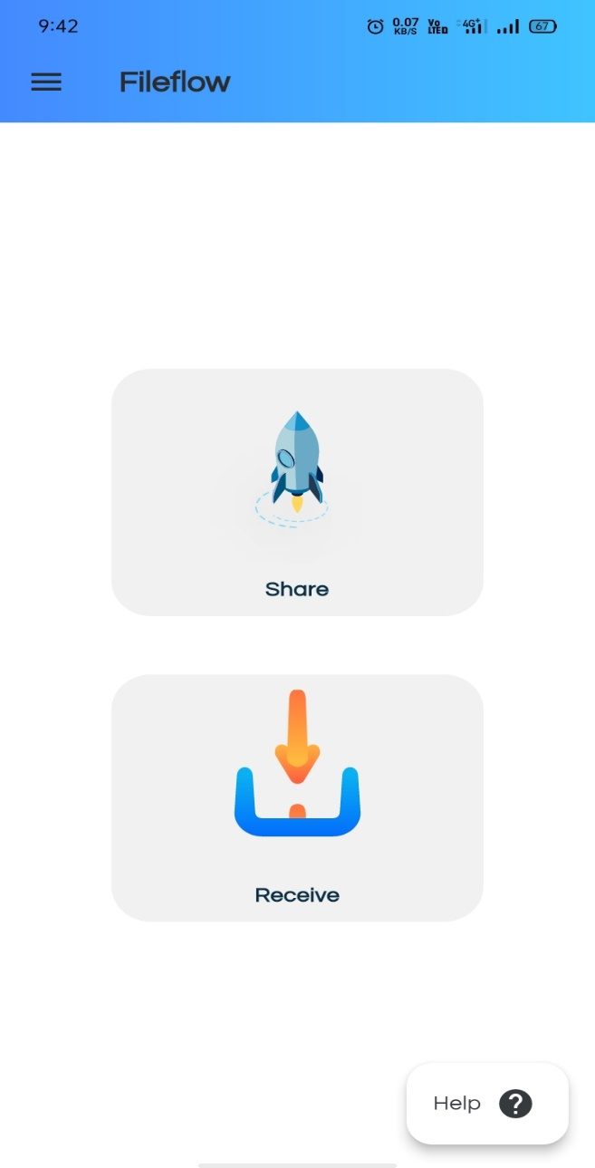 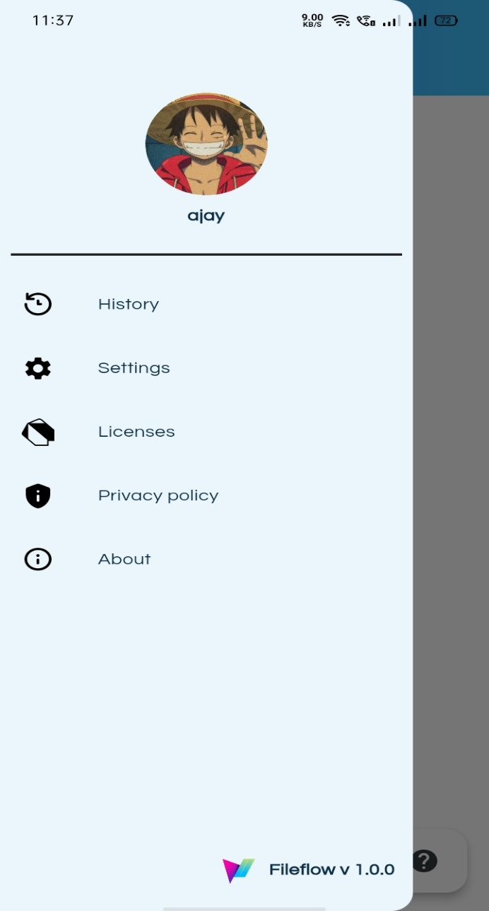

4.3. Share Option: 4.4. Send Option:

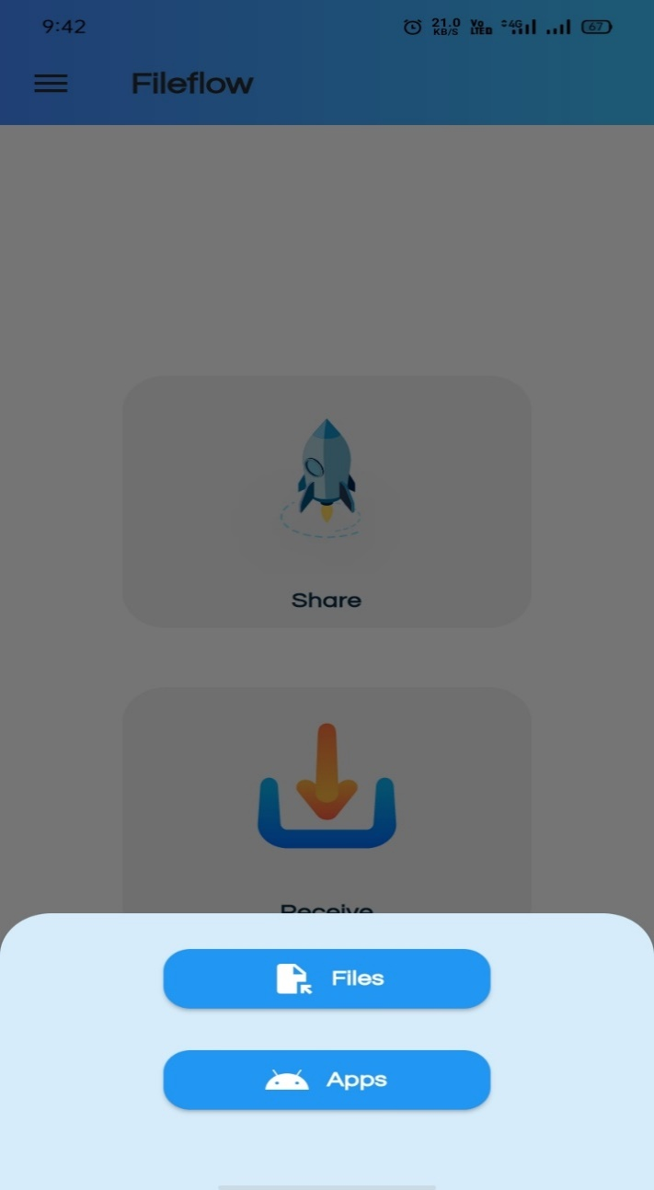 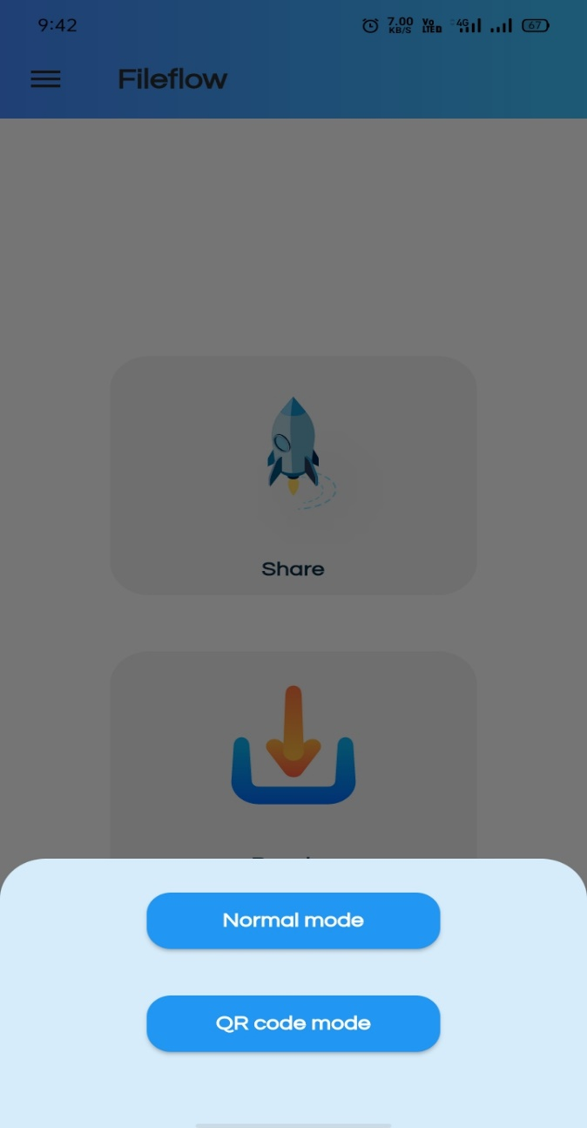

4.5 Send and Received History Page

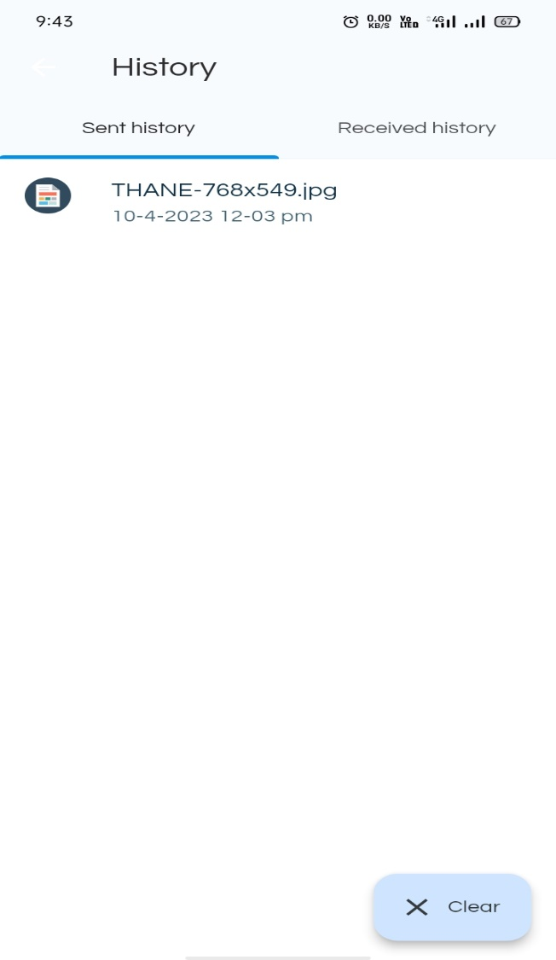

The result of a file sharing app is to provide a secure, efficient, and accessible platform for users to share and store files.

**Chapter 5**

**Conclusion and Future Scope**

**1. Conclusion:**

The benefits of file sharing software are so many that many companies cannot ignore it. Essential for developers to prioritize implementation of robust security measures, ample storage space, and easy-to-use design. In conclusion, a file sharing app can be a valuable tool for organizations and individuals who need to share and store files securely and efficiently. With the growing demand for remote work and collaboration, file sharing apps have become increasingly popular due to their ability to facilitate teamwork and productivity across different locations and time zones.

**2.** **Future Scope:**

**Enhanced features:** File share app can continue to develop new and enhanced features to improve the user experience, such as better integration with cloud storage services, improved file compression, and advanced security features.

**Increased platform support**: File share app can expand its platform support to include new and emerging operating systems, such as Chrome OS, Linux, and IoT devices.

**Blockchain technology**: Blockchain technology could be used to create a more secure and transparent file sharing platform. By using a decentralized ledger, file sharing apps could reduce the risk of data breaches and improve accountability.

**Improved mobile experience**: As more user’s access files and collaborate remotely using their mobile devices, file sharing apps will need to prioritize mobile optimization and functionality to ensure a smooth user experience.

**References**

**Links:**

* **Prof. Shantanu “Xender Application” (2016).**
* [**https://ieeexplore.ieee.org/abstract/document/8082672/references#references**](https://ieeexplore.ieee.org/abstract/document/8082672/references%23references)
* **Prof. Alexander “BitTorrent” (2017).**
* **<https://ieeexplore.ieee.org/abstract/document/8038462>**
* **Tiddi, I., & Reale, M. (2018). File sharing for collaborative working: A systematic literature review. Computers in Human Behavior, 80, 300-312.**